Museum of Ancient Cultures, University Tübingen.
Ahmad Aroud
2023-04-28
Table of contents

1. Museum of Ancient Cultures, University Tübingen
Author: Ahmad Aroud
ORCID: https://orcid.org/0009-0000-3344-9566
Date: 25.06.2023
DOI: 10.5281/zenodo.7875479
Repository URL: https://github.com/AhmadAroud/catalogue-003

1.1 Based on Baroque AI: Publication Prototype

1.2 Part of the series: Baroque TOC
Programme instructions
2023-03-17
This work is licensed under a Creative Commons Attribution-ShareAlike 4.0 International License.
Book cover: Reworking of Baroque pearl with enamelled gold mounts set with rubies. Creative Commons CC0 1.0 Universal Public Domain Dedication. This file was donated to Wikimedia Commons as part of a project by the Metropolitan Museum of Art.

This work is licensed under a Creative Commons Attribution-ShareAlike 4.0 International License.

2. Colophon
Fork title: AhmadAroud/catalogue-003
Author: Ahmad Aroud
ORCID: https://orcid.org/0009-0000-3344-9566
Date: 28.04.2023
DOI: 10.5281/zenodo.7875479
Repositor: https://github.com/AhmadAroud/catalogue-003
PUBLISHING FROM COLLECTIONS USES OF COMPUTATIONAL PUBLISHIGN AND LINKEDOPEN DATA
Open Science Lab - TIB Hannnover
First published 2023-03-30
Copyright © The Authors 2023 Licensed as https://creativecommons.org/licenses/by-sa/4.0/
DOI: https://doi.org/10.5281/zenodo.7701161

3. Museum of Ancient Cultures, University Tübingen.
Source: https://www.unimuseum.uni-tuebingen.de/en/museum-at-hohentuebingen-castle/museum-ancient-cultures
Admire many superlatives of cultural history such as the oldest figurative art of mankind (UNESCO World Heritage “Ice Age Art”) or the oldest musical instrument in the world in the Museum Ancient Cultures in the Hohentübingen Castle. Learn more about the UNESCO World Heritage Site “Pile Dwellings”, the Egyptian offering chamber of Seschemnefer III, the “Tübingen Hoplite” and the Malanggan artworks from New Ireland.

4. Data Visualization
Visualization.
Here an image of my data viz : 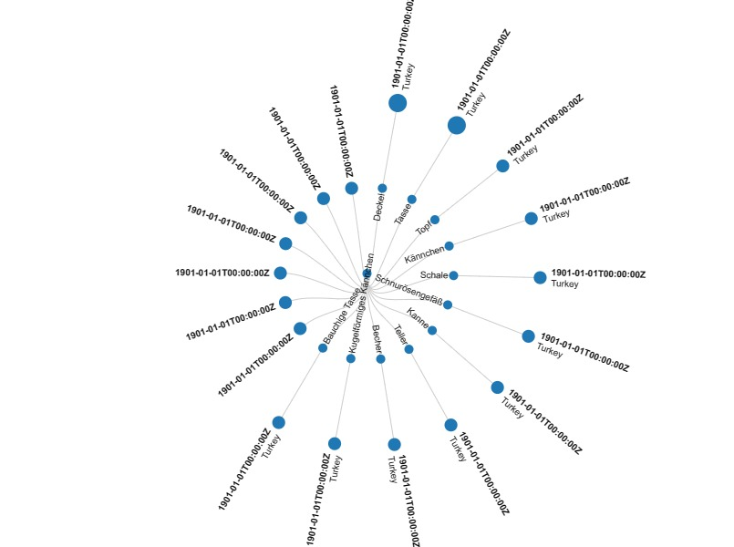
Here is an iframe with some data viz:

5. Activity: Paintings catalogue
Wikidata link: http://www.wikidata.org/entity/Q119423701
Title: Topf
Year: 1901-01-01T00:00:00Z
Discoverer: Johann Heinrich Ludwig Petersen
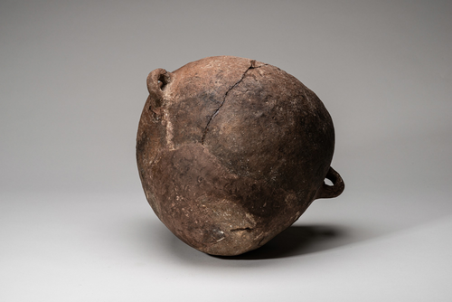
Wikidata link: http://www.wikidata.org/entity/Q119423703
Title: Deckel
Year: 1901-01-01T00:00:00Z
Discoverer: Johann Heinrich Ludwig Petersen
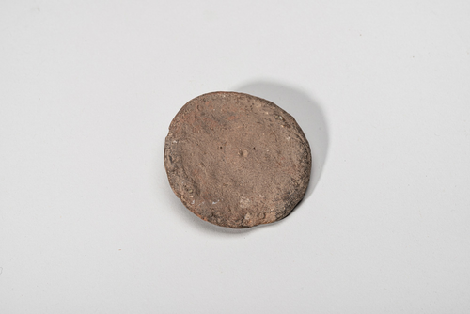
Wikidata link: http://www.wikidata.org/entity/Q119423703
Title: Deckel
Year: 1901-01-01T00:00:00Z
Discoverer: Johann Heinrich Ludwig Petersen
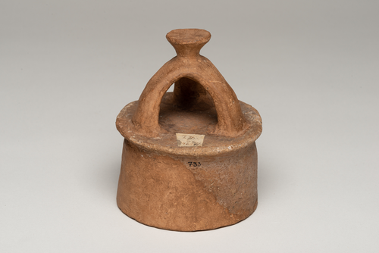
Wikidata link: http://www.wikidata.org/entity/Q119423705
Title: Kännchen
Year: 1901-01-01T00:00:00Z
Discoverer: Johann Heinrich Ludwig Petersen
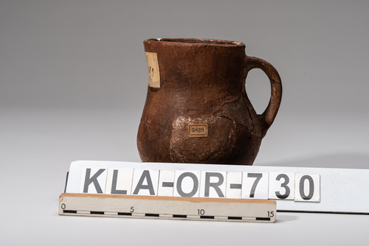
Wikidata link: http://www.wikidata.org/entity/Q119423706
Title: Schale
Year: 1901-01-01T00:00:00Z
Discoverer: Johann Heinrich Ludwig Petersen
KeyError: 'image'

